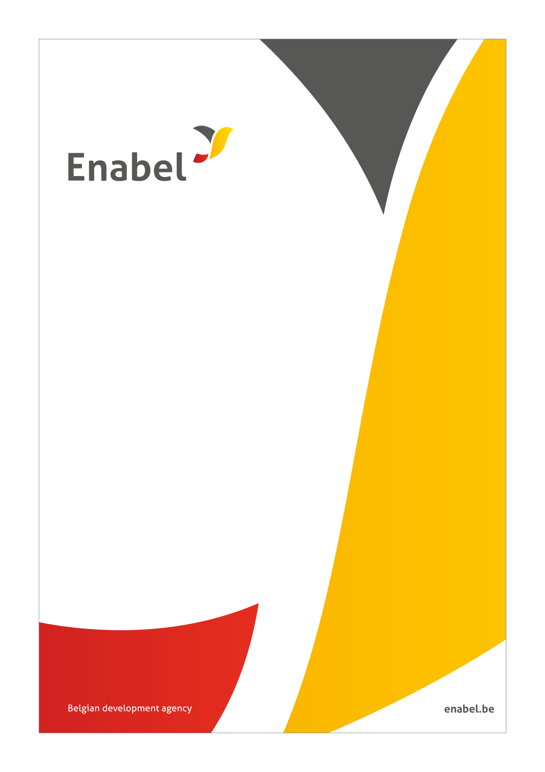

SALE OF USED MOTOR VEHICLES

Kindly return this Bid document properly filled and signed. Bid documents returned without detailed information will be deemed Null and Void.

Enabel is implementing a Uganda Country Portfolio 2023-2028 under the Uganda-Belgium Cooperation Agreement mainly focusing on the sectors of Education, Health, Skills Development and Employment as well as cross-cutting areas such as Digitalization, Gender and Climate.

The Enabel Kampala Representation office invites bids from interested bidders for Sale of 02 used Motor Vehicle unit detailed below.
# | #Plate | Make | Model | Chassis number | YOM | Location | Links to vehicle image
1 | UAX453Z | Toyota | RAV4 | JTMBFREV20J038341 | 2015 | Kampala | http://gofile.me/6QZru/yJOiWeMli
2 | UAT 912X | Suzuki | Vitara | JSAJDA4V00219477 | 2011 | Kampala | http://gofile.me/6QZru/wXQhNVB0t

TERMS AND CONDITIONS
The above vehicles will be available for viewing and inspection from 10:00 a.m. – 4:00 p.m. from Monday 10th August to Friday 21st August 2026 at our ofﬁces located at. Plot 1B, Lower Kololo Terrace, Kampala, Uganda, P.O. Box 40131. Viewing shall strictly close at 4:00 pm From Monday to Friday of every week and shall not be possible on weekends.

Furthermore, customs and import duties must be paid on the said vehicle to the Uganda Revenue Authority as they were purchased duty free. The vehicle will only be released by Enabel to the successful buyer after proof of payment of taxes and issuance of new registration number plates for the vehicles.

Please note that the terms of vehicle sale shall be Sale shall be on a competitive basis and strictly “as is” where is” basis with no guarantee or warranty expressed or implied as to its current condition. There will be “no refunds” made after payment for the above vehicle.

Bidders will be required to submit their bids forms (on page two) by email to: UGA_logisticsmanagment@enabel.be not later than 25th August 2026 by 4p.m.

The subject line must be: “PURCHASE OF USED VEHICLE” and the file name of the attachment should be in the buyer’s names.

A one-page Bidding Form, procedure guidelines and vehicle images are available for free (at no cost) share point as per the shared link.

Enabel reserves the right to reject any bid and is not bound to accept the highest offer or sale to any other bidder.

The Successful bidder will be required to deposit a commitment fee of 50% of the total offer to Enabel, Belgian Development Agency within in 5 working days of the offer and the balance within 5 working days after acceptance of the offer failure of which may lead to cancellation of the offer. Bank account details will be provided to the successful bidders.

On full payment, the buyer must remove the vehicle from Enabel premises at Plot 1B, Lower Kololo Terrace, Kampala, Uganda, P.O. Box 40131 only after effecting payment and presenting proof of payment for the relevant taxes.

Enabel is not bound to accept the highest or any bid under any circumstances.

BID FORM
(Film out all details as required and submit)

PART A

I _______________________________________________ hereby submit my offer for purchase of the following motor vehicle;

Vehicle Make & Model
Chassis Number
Registration Number
Bid Offer (UGX)
Amount in words

Identification of the Bidder (Company or individual where applicable)

Name of Bidder: ______________________________________________________

Address: _____________________________________________________

Country: _____________________________________________________

Company URSB registration Number: _______________________________________

National Id Number: _________________________________________________
Mobile Number: ___________________________________________________

Email address: ______________________________________________________

Date: __________________________

Bidder’s Signature and stamp: ________________________

Required supporting Document:

- Bidder`s National identity card (For individuals) or Certificate of Incorporation (for companies)
- Tin Certificate (For companies)
- Powers of attorney for (Companies)
- Tax Clearence certificate (companies)

